
Mobilisation 5 February – Communication planning

IndustriAll Europe and its affiliates are mobilising on February 5th for investment into good industrial jobs ahead of the announcement of the clean industrial deal by the European commission on February 26th.
We denounce the various austerity policies that only accentuate the crises and have, until proven otherwise, never provided the slightest solution in terms of economic recovery.

We demand a real European industrial plan, which does not seek to follow or choose between China or the United States, but of a Europe which takes back its destiny by hand relying on investments and research and development.

The mobilisation will be static. It will have a strong visual identity and will target the European Commission. A lot of people will attend. Unions from across Europe have committed to send approximately 2500 people and the Belgian unions have committed to fill the rest of the square for a static demonstration.

Communication material/branding

- Slogan: Invest in good industrial jobs
- Hashtag #GoodIndustrialJobs
- the ‘good industrial jobs’ campaign flyer (link)
- a 2–3-minute animation with voice over (and subtitles) of why we are mobilising
- a teaser video for the mobilisation
- social media cards
- model letter for MEPs

Teaser Video

We will produce an animated film to promote the demonstration. Workers from different sectors will be filmed walking towards the location of the demonstration with props. We have received the contact details of all the workers and will soon contact them with details on the location time and place of filming. The video will be played before and during the demonstration on a big screen. We encourage that this video is shared widely by affiliates on social media.

Campaign video

We will release a campaign video setting out our demands (as agreed by the Executive Committee in Porto) on Friday 10th January. There are 5 emergency actions to avoid deindustrialisation and 5 pillars of a real Industrial Deal. We encourage you to share it widely on social media. The video will be played during the demonstration on a big screen.

Video testimonies

We would like affiliates from across Europe to send us short video testimonies from workers at different sites calling for European action and describing the situation in their site/country (maximum 90 seconds long). We would need the first name of the worker and the country to accompany the videos. These videos will be collected and played on a screen during the demonstration. The videos will additionally be used separately on social media to highlight the industrial crisis across Europe.

Filming during the demonstration

We are planning to film testimonies of people during the demonstration talking about why they are mobilised and their demands towards the European Commission. A cameraman together with someone from the industriAll Europe staff will go around and interview people individually. This footage will be used in the run up to the announcement of the clean industrial deal on February 26 as well as on social media. We’d like all unions/countries present to be included.

The rally

We will ask all affiliates who are unable to attend to send us a flag of their union that will be held by another participant during the demonstration to ensure all unions are visible.

There will be food trucks available at the rally.

A screen and stage will be at the square and a camera team will be there on the spot to film the crowd as well as the speeches and display them on the screen.

Press

The industriAll Europe comms team will contact our press contacts ahead of the demonstration to invite them as well as to explain why we are mobilising and what our demands are and to ensure we have a wide coverage of the day. Please use your press and media contacts to draw attention to our common demands and the mobilisation.

Social media suggestions
LinkedIn Post Suggestion:
IndustriAll Europe calls for unions across Europe. Join us on 5th February in Brussels to fight for Europe's industrial future! Secure jobs, protect industries, and ensure a sustainable and resilient Europe.

10.30 AM, at Place Jean Rey.
We have identified five crucial actions to prevent deindustrialisation:
1. Protect our workforce and industrial capacity.
2. Invest and reassess fiscal rules to fund social and clean transition initiatives.
3. Use public procurement to boost demand.
4. Bridge the investment gap with EU funds.
5. Ensure industrial resilience in global markets to combat overcapacity, unfair trade and protect jobs.
Our industries are the backbone of Europe's economy. IndustriAll Europe demands a comprehensive European industrial investment plan which does not seek to follow or choose between China or the United States, but of a Europe which takes back its destiny by hand relying on investments and research and development.

This plan must include:
- A Just Transition Compass prioritizing training for a fair shift to sustainable industries.
- A comprehensive industrial investment plan that embeds social conditionalities in all public investments.
- The right to energy at home and work.
- Strengthened collective bargaining and worker participation.
- Global supply chain guarantees ensuring fair purchasing practices and human rights due diligence.
#GoodIndustrialJobs #Industrialfuture #IndustriAllEurope
---------------------------------------------------------------------------------------------------------
Facebook Post Suggestion:
Europe’s industrial future is under threat. Join us in Brussels at 10.30 on 5th February in Place Jean Rey to defend our industries and jobs. IndustriAll Europe calls for unions across Europe. Together, we can make a difference!
Example photos:
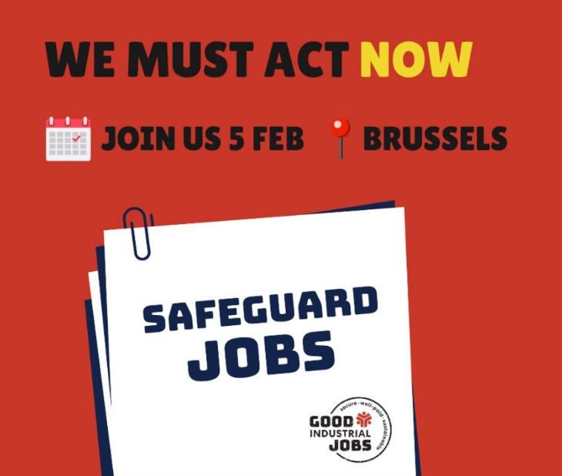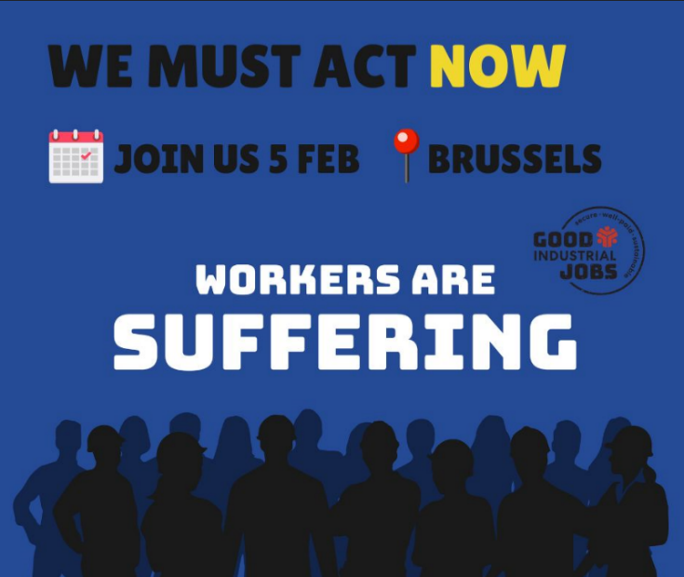
--------------------------------------------------------------------------------------------------------
Bluesky Post Suggestion:
Make a Real Industrial Deal. Our industries are the backbone of Europe's economy. IndustriAll Europe calls for unions across Europe to Stand with us on 5th February in Brussels to demand a real industrial deal for Europe. Protect jobs, invest in our future! IndustriAll Europe demands a comprehensive industrial investment plan. Check what the plan should include: LINK TO WEBSITE #GoodIndustrialJobs

---------------------------------------------------------------------------------------------------------
Instagram Suggestion:
We need to act now! Europe’s industrial future is under threat. Join us in Brussels at 10.30 on 5th February, in Place Jean Rey to defend our industries and jobs. IndustriAll Europe calls for unions across Europe. Together, we can make a difference! #GoodIndustrialJobs

Model letter to send to MEPs

Dear Member of the European Parliament,
Invitation to Join the Fight for Europe's Industrial Future
On February 5, workers from all over Europe will demonstrate in Brussels for their future. Organized by industriAll Europe we demand a proactive European industrial policy based on investment, solidarity, quality jobs, and innovation, in line with our climate commitments. Speaking for 7 million working men and women united within more than 200 national trade union affiliates in 39 European countries, workers will set out our joint demands.
Our industries and jobs are under threat, and deindustrialisation is no longer a distant possibility but a harsh reality. It’s time to change the record and fight for Europe's industrial future. We denounce the various austerity policies that only accentuate the crises and have, until proven otherwise, never provided the slightest solution in terms of economic recovery. We want a real European industrial plan, which does not seek to follow or choose between China or the United States, but of a Europe which takes back its destiny by hand relying on investments and research and development.
Come and join us! Show your support. The demonstration will take place from 10.30 on February 5th, at Place Jean Rey in Brussels. Appeals will be held by representatives of trade unions from all over Europe. The press are also invited.
Our important message - 5 Crucial Actions to Prevent Deindustrialisation today:
- Protect our workforce and industrial capacity.
- Invest and reassess fiscal rules to fund social and clean transition initiatives.
- Use public procurement to boost demand.
- Bridge the investment gap with EU funds.
- Ensure industrial resilience in global markets to combat overcapacity, unfair trade, and protect jobs.
Make a Real Industrial Deal for the future!
Our industries are the backbone of Europe's economy. IndustriAll Europe demands a comprehensive industrial investment plan. This plan must include:
- A Just Transition Compass prioritizing training for a fair shift to sustainable industries.
- A comprehensive industrial investment plan embedding social conditionalities in all public investments.
- The right to energy at home and work.
- Strengthened collective bargaining and worker participation.
- Global supply chain guarantees ensuring fair purchasing practices and human rights due diligence.
Together, we can build a resilient, sustainable Europe with good industrial jobs for all.
Please join us in Brussels on the 5th of February. Your presence and support are crucial in making a difference and securing the future of Europe's industries. If you can’t join us, please show your support on social media by posting and tagging us on Facebook industriAllEU, LinkedIn industriall-europe, Instagram industriall_europe, Bluesky @industrialleurope.bsky.social (X @industriAll_EU): #goodindustrialjobs.
Kind regards, [Your Name] [Your Position] IndustriAll Europe

Second model letter to send to MEPs

Dear Member of the European Parliament,
The Fight for Europe's Industrial Future:
Parliament Members Called to Action!
Request for a meeting
On behalf of 7 million workers united within over 200 national trade union affiliates in 39 European countries, industriAll Europe demand a proactive European industrial policy founded on investment, solidarity, quality jobs, and innovation, aligned with our climate commitments. Our industries and jobs are under threat, and deindustrialisation is no longer a distant possibility but a harsh reality. It's time to change the record and fight for Europe's industrial future. We denounce the various austerity policies that only accentuate the crises and have, until proven otherwise, never provided the slightest solution in terms of economic recovery. We want a real European industrial plan, which does not seek to follow or choose between China or the United States, but of a Europe which takes back its destiny by hand relying on investments and research and development.
On February 5, workers from across Europe will demonstrate for their future in Brussels. They are members of trade unions from several European countries – together we are calling for urgent action to avoid deindustrialisation:
- Protect our workforce and industrial capacity.
- Invest and reassess fiscal rules to fund social and clean transition initiatives.
- Use public procurement to boost demand.
- Bridge the investment gap with EU funds.
- Ensure industrial resilience in global markets to combat overcapacity, unfair trade, and protect jobs.
As a member of the European Parliament, you are invited to meet us, to listen and support. The demonstration will take place at Place Jean Rey in Brussels. Appeals will be delivered by trade union representatives from across Europe. Whether you have the opportunity to join or not to, we like to arrange a meeting with you as soon as possible to discuss opportunities and solutions.
Urgent: Make a Real Industrial Deal for our future!
Our industries are the backbone of Europe's economy. IndustriAll Europe demands a comprehensive industrial investment plan. This plan must include:
- A Just Transition Compass prioritizing training for a fair shift to sustainable industries.
- A comprehensive industrial investment plan embedding social conditionalities in all public investments.
- The right to energy at home and work.
- Strengthened collective bargaining and worker participation.
- Global supply chain guarantees ensuring fair purchasing practices and human rights due diligence.
Together, we can build a resilient, sustainable Europe with good industrial jobs for all. Let us know when we can have a meeting with you.
Let’s act now! Invest in #goodindustrialjobs.
Kind regards,
[Your Name] [Your Position] IndustriAll Europe / affiliate organization
E-mail
Phone

